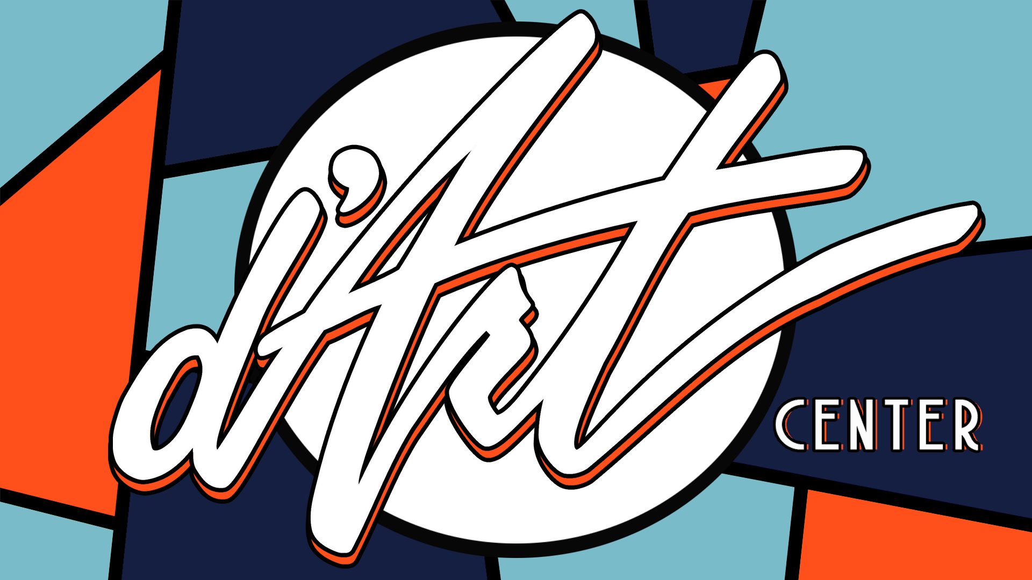

Workshop/Class Proposal Agreement

This is an agreement between FIRST NAME LAST NAME and The d’Art Center for WORKSHOP TITLE on DATE from TIME. Please review the details below, sign and return to Deanna Strother at dstrother@d-artcenter.org. We look forward to working with you and offering this great opportunity to our community!

Artist Name & Info
First Name:
Last Name:
Phone Number:
Email Address:

Artist Social Media/Website:

Workshop/Class Information
- Workshop or Class:
- Workshop/Class Title:
- Class/Workshop Date(s):
- Class/Workshop Times:
- Preferred Student Age Range:
- Maximum # of Students:
- Minimum # of Students Required by d’Art Center:
- Who is Purchasing Supplies (add a student supply list if applicable):
- Suggested Cost of Class Ticket (per person):
- Student Experience Level Required for Class:

Class/Workshop Description:

Cancellation Clause:
If the Minimum # of Students Required by d’Art Center is not met 14 days prior to the workshop, the d’Art Center may cancel the workshop.

Additional Information:
- Start a waitlist for any students that want to take the class after the Maximum # of Students has been met.
The Artist approves the above information and has read and agrees to the 2026 d'Art Class/Workshop Proposal Info

Name: _____________________________ Date: ______________________
Artist Signature: ____________________________
D’Art Staff Signature: ________________________

